Software Requirements Specification  
_______________________________

Any Kitchen



Glossary

Problem Description……………………………………………………………………………2

Purpose……………………………………………………………………………………………….2

User Characteristics…………………………………………………………………………….2

Functional Requirements…………………………………………………………………….3

Non-Functional Requirements…………………………………………………………….3

Context Diagram………………………………………………………………………………….4

Use Case Diagram………………………………………………………………………………..5

Use Case List………………………………………………………………………………………..6

Data Flow Diagram………………………………………………………………………………7

Data Collection Methods……………………………………………………………………..8

Interview Questions…………………………………………………………………………….9

Interview Answers……………………………………………………………………………..10

Survey Results……………………………………………………………………………………11

Online Traffic Monitoring…………………………………………………………………..13

Software Capabilities…………………………………………………………………………14

Operating Environment………………………………………................................14

Constraints………………………………………………………………………………………..15

Gantt Chart………………………………………………………………………………………..16

Problem Description

Many people who like to cook at home go shopping but either forget to write down what they need or look at what ingredients they already have. This can lead to people buying ingredients they do not need and wasting food or not buying sufficient ingredients and having to leave the house to go shopping once again. Many people also forget to where they put their recipes or accidentally through them out. These people require a software solution that allows them to easily track what ingredients they require by keeping track of what ingredients are needed and easily store their favourite recipes to be accessed at any time.

Purpose

The purpose of this software solution is to keep track of the user’s ingredients and to calculate what ingredients and quantities they do and do not need. The software will also list what ingredients are needed enabling the user and to filter the list and show certain recipes enabling the user to quickly to see what they need to make their favourite recipes. There may be opportunities to include ways for users to browse white goods and share their favourite recipes with others

User Characteristics

The audience will include individuals with windows 10 machines in the general public who have a desire to track their ingredients and has a like to prepare food from home, people who design or share recipes and providers of white good who want to advertise their products.

General Users of any gender will have to moderately familiar with the idea of saving and updating data within applications as well as the general navigation of applications. They will need to speak English and be familiar with food measurements such as kg, cups or tbsp. and cooking terminology. The user will also have to be proficient in the use of a keyboard wither physical or on screen to enter data into the application and navigate. Users will also have to be motivated to update the app and following recipe accurately to make sure the stored data is correct.

Recipe designers will need to be proficient in data entry and require access to an android or windows enabled device to upload recipes. To fulfill this characteristic, recipe designers must also be able to use a keyboard to enter recipe details such ingredients, quantities or needed kitchen equipment.

White good providers like recipe makers will need to be proficient in data entry and uploading images to advertise their products.

Functional requirements

|  |  |  |
| --- | --- | --- |
| No | Requirement | Notes |
| FR01 | Enable all users to save their favourite recipes and add to their shopping list |  |
| FR02 | Save and organise data | Using arrays and read and write functions to save data |
| FR03 | Create printable forms for the user | The user will need free space on their device to have space for the files the application will create |
| FR04 | Display and filter list of items | The application will have to read data from saved files and then display them to the user according to what filter is currently applied |
| FR05 | Save Recipes and their ingredients |  |
| FR06 | Keep track of current date | This will assist in timing the creation and details of files |
| FR07 | Functional user interface |  |

Non-Functional Requirements

|  |  |  |
| --- | --- | --- |
| No | Requirement | Notes |
| NFR01 | Attractive user interface | Consistent colour palette |
| NFR02 | Data entry shortcuts | Auto filling information when entering data |
| NFR03 | Input response |  |
| NFR04 | Easy access to files in order fix or remove data | Organised source code and filing system |
| NFR05 | Organised file read and write functions |  |
| NFR06 | Fast read and write speeds to storage files | Limited to the user’s device storage read and write speed |
| NFR07 | Enable normal users to create their own recipes |  |
| NFR08 | Layout printable files in a visually appealing manner |  |
| NFR09 | Allow shopping list to adapt to current date and time | Add and subtract certain data from shopping list file according to the date it is being printed |

Context Diagram



**User**



**Recipe Maker**

Recipe Printout

Recipes

Recipes

Shopping List Updates

Shopping List Printout

Any Kitchen Application

Sales Report

White Good Details



**White Good Provider**

Use Case Diagram

Recipe Database

**Any Kitchen Application**



**User**

Store Recipe on user’s device

Displays Database

Browse Recipes



**Recipe Maker**

Upload Recipe

Make Recipe

Save Recipe

User Profile

View Recipes

Print Recipe

View Wishlist

Print Shopping List

Update Pantry

User Storage

Save White Good

Browse White Goods

Displays Database



**White Good Provider**

White Good Database

Upload White Good details

|  |  |  |
| --- | --- | --- |
| No | Use Case | Details |
| UC01 | Browse Recipes | Lists all recipes stored in recipe database for the user to observe |
| UC02 | Save Recipe | Save selected recipe to user profile and user device |
| UC03 | Browse User Profile | Browse user profile and all stored data categorised |
| UC04 | View Recipes | View stored recipes |
| UC05 | Print Recipe | Print stored recipe |
| UC06 | View Wishlist | View Wishlist of saved white goods |
| UC07 | Print Shopping List | Print list of ingredients needed for selected recipes |
| UC08 | Make Recipe | Make a recipe and upload it to recipe database |
| UC09 | Browse White Goods | List all white goods for the user to observe |
| UC10 | Save White Good | Save selected white good to Wishlist |
| UC11 | Upload White Goods | Enter White Good details and upload them to White Good database |

Use Case List

Data Flow Diagram

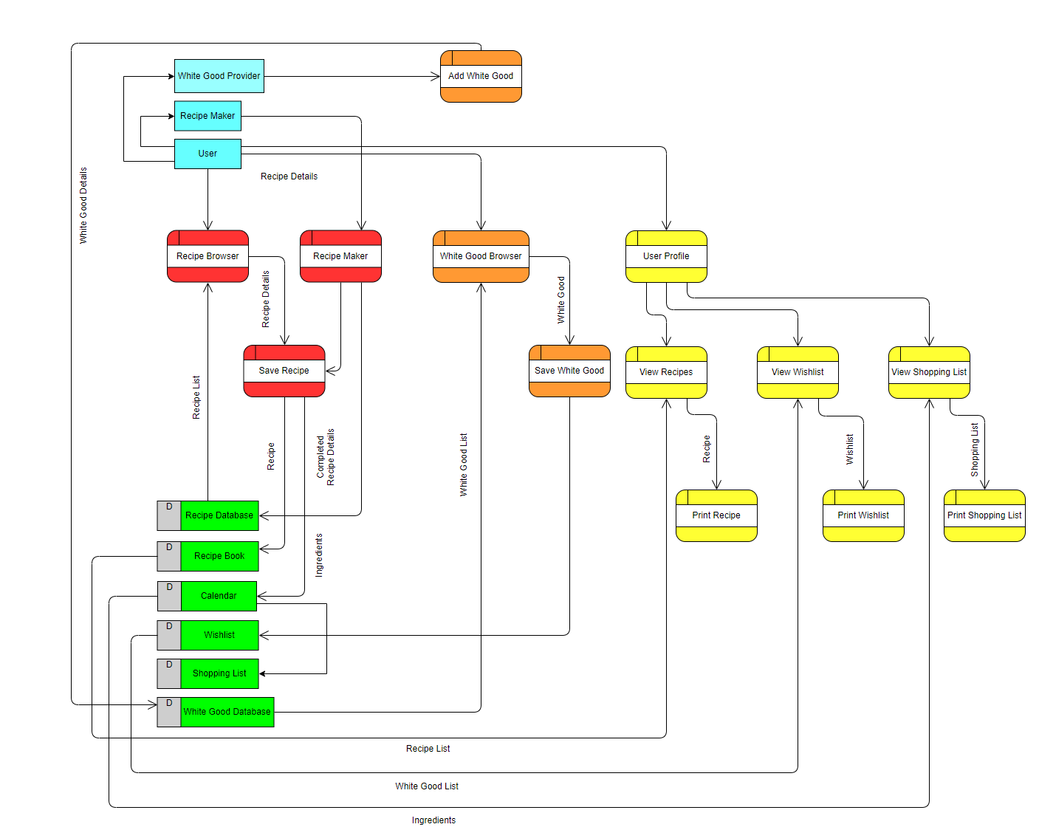

Data Collection Methods

|  |  |
| --- | --- |
| **Collection Method** | **Justification** |
| Interview | To investigate exactly what people, desire in the application such as features, Open ended questions as well as questions that would lead to quantitative data will be asked. The pre-prepared nature of an interview allows the collection of specific qualitative and quantitative date while still be under supervision increasing the quality control of said data |
| Surveys | Surveys may not be as effective in quality assurance as interviews but they can be fulfilled in mass by ,many participants through online or real world advertisements creating and large data set to be analysed and considered in future decision making throughout the development of the application |
| Online Traffic Monitoring | By monitoring online traffic of popular recipe websites, we will be able to track the desire for the application, common features among popular websites as well as the user base itself |

Interview Questions

1.How often do you make meals at home?

2. Do you often forget what to buy when shopping for ingredients?

3. Do you write a list when going shopping for food?

4. How many times a week do you go shopping for food?

5. Do you regularly use certain websites for recipes?

6. Would an easy way to track your ingredients make you motivated to cook more at home?

7. Would you be more likely to use a list on your phone when shopping or a piece of paper?

8. Do you think an application used to share recipes and track ingredients would make it easier to cook at home?

9. How do you currently store your recipes?

10. What is the position of the person who cooks the most in your family?

11. What features would an application used to track ingredients and recipes would you like to be incorporated?

12. Do you often find that you do not have the necessary kitchen tools to make a recipe?

13. Do you find subtle targeted advertising to be helpful or ineffective?

14. How likely would you be to use an application on your main desktop computer or laptop rather then your phone if it were available on both platforms?

15. Do you believe social media integration is essential in a recipe sharing platform?

16. What websites or applications do you believe have a good looking and easy to use user interface?

Interview Answers

**Michelle Wood/35/ 22nd April 2020**

1. I prepare meals around 5-6 times a week and often go for takeaway of Friday or Saturday nights because its nice to not cook once or twice a week and I can try different types of food that I don’t know how to cook

2. I usually remember what I need but when I am making a new recipe with unique ingredients, I usually forget something important which can be a real pain

3. Yes, I usually write a list unless I am just getting something on the way home from work

4. I like to only go oncer a week but usually I go twice or even three times to pick up the essentials or stuff that I did not think of

5. I like to watch Gordon Ramsay’s videos on YouTube and write them down

6. It would make it easier, but I do not think it would really make me more motivated as it is a lot of work to cook full meals

7. I like to use the notes app on my iPhone

8. I think many apps already make it easy to share recipes like Facebook and Instagram and it would not make the physical process easier

9. I keep them in a folder in my pantry

10. I cook the most and my husband cooks occasionally

11. I would like it to tell me exact quantities of ingredients I need so that I do not have random jars and bags of ingredients laying around that I will not use again

12. I occasionally lack stuff like a lattice roller when making pastry, but I have most other things that I could need

13. When it works well, I think its effective but in most cases I just ignore it because it does not advertise anything, I would purchase

14. If it is available on my phone, I will not even bother downloading it on my laptop because I do not carry my laptop with all the time like I do with my phone

15. I do not think it is essential, but It would help in sharing of recipes

16. I really like the user interface of WhatsApp Instagram, and the Google Chrome app on my iPhone

Survey Results

Online Traffic Monitoring

|  |  |  |  |  |  |
| --- | --- | --- | --- | --- | --- |
| Website | **Taste.com.au** | **Bestrecipes.com.au** | **Allrecipes.com** | **Delicious.com.au** | **Epicurious.com** |
| Total Visits | 11,630,000 | 2,900,000 | 116,430,000 | 1,830,000 | 13,100,000 |
| Top Traffic Source | Google Search | Google Search | Google Search | Google Search | Google Search |
| Top Social Media Platform Referral | Facebook | Facebook | YouTube | Facebook | Facebook |
| Average Pages Per Visit | 2.78 | 3.33 | 2.11 | 4.96 | 1.69 |
| Top 3 Organic Search Words | Taste  Banana Bread Recipe  Dinner Ideas | Anzac Biscuits  Pizza Dough Recipe  Peanut Butter Cookies | Allrecipes  Banana Bread Recipe  Pancake Recipe | Recipes  Pork Mince Recipes  MasterChef Recipes | Epicurious  Charoset Recipe  Panna Cotta |

Software capabilities

* Save and display recipe details
* Save and display white good details
* Enable user to save recipes and white good to personal lists
* Calculate and display a user shopping list
* Calculate and display white good Wishlist
* Enable recipe makers to enter new recipes
* Enable white good providers to enter new white goods
* Track the date and time enabling appropriate items to be placed on the shopping list
* Limited to android and windows devices
* Create printable shopping lists, recipes and wish lists

Operating environment

|  |  |  |  |
| --- | --- | --- | --- |
| **Hardware** | Desktop and Portable Computers  **Storage:** Solid State/Hard Drive (<5GB)  **Processor:** i5 8400  **Ram:**  4GB | Printer | Host Server  **Storage:** Solid State/Hard Drive (<500GB)  **Processor:** i5 8400  **Ram:**  4GB |
| **Operating System** | Windows 10 | Updated Drivers | Windows 10 |
| **Software Applications** | Adobe Acrobat (or any other application opening PDF file format |  | Adobe Acrobat  Microsoft Visual Studio |
| **Other** | Internet Connection | Internet Connection |  |

Constraints

Economic

The application will initially be tested on basic windows 10 desktops and one android device due to the large investment that would be necessary to fully launch and support the app during development

Time

Certain non-essential functions may not be fully implemented or realised due to the short amount of time dedicated to software solution

Social

The collection of data may be difficult due to the COVID-19 outbreak limiting certain aspects such as face to face interviews being conducted over video call or email. The app will also initially be limited in the number of users as the amount of storage space on the future central server will only contain 500gb of space

Legal

Ownership of recipes may be an issue with sharing and saving them on a users devcice

